
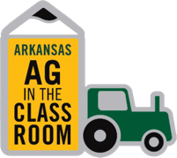

in cooperation with the

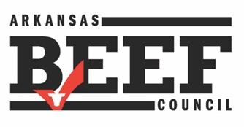

DATE: August 19, 2025

TO: Family & Consumer Science Teachers

FROM: Donette Spann, Director, Ag in the Classroom

RE: Beef in the Classroom Grant Program

Welcome back, teachers! Thank you for everything you do to educate students. We appreciate you!

The Beef in the Classroom Grant Program began 22 years ago in Arkansas! Over $230,000 has been awarded to teachers who enjoy teaching about beef. In a partnership with the Arkansas Beef Council, Arkansas Farm Bureau and the Ag in the Classroom program bring you this opportunity. We will soon be accepting applications for the 2025-26 school year. To access the application:

Application link: https://forms.office.com/r/iQZS1kDj5i

*Only Arkansas FACS teachers are eligible. Applications open on Monday, September 8, 2025, at 8 a.m. Applications close on September 19, 2025, at 4:00 p.m.

Please read over the requirements and conditions on the attached page.

The grants are for $100 to cover beef and ingredient costs.

If you have any questions, contact me at 501-228-1222, or (cell) 501-804-8222, or email me at donette.spann@arfb.com. I look forward to working with you and helping you teach your students about beef.

Thanks!

Attachment


beef in the classroom grant program
2025-26

Purpose
Beef in the Classroom is a grant program designed for Family and Consumer Sciences classes. Its goal is to provide funding for buying beef products for these classes. The program supports lessons on selecting, storing, preparing, nutrition, and food safety of beef.
Guidelines
- Beef in the Classroom funds ($100) are awarded to FACS teachers of foods, nutrition, or related courses who are teaching a unit on BEEF. There are 150 total grants available this year.
- Funds are available for middle school, junior, and senior high school FACS classes.
- Grant money can be used to purchase beef products and ingredients needed for recipes or dishes.
- The grant must be used by the end of the 2025-2026 school year. One grant per teacher per school year.
Procedures
- Only FACS teachers are eligible for the grant program.
- Grants are available on a first-come, first-served basis. Applications will be accepted online starting September 8, 2025, at 8 a.m. The application system will not open before this time.
- Applications are only available online. Please do not share them with non-FACS teachers. Applicants will be verified through the Arkansas Department of Education—Family and Consumer Science Department.
- Evaluations must be submitted by June 30, 2026, to be eligible for the 2026-2027 program. After completing the beef unit, a copy of receipts for beef purchases and recipes used (including pictures if possible) should be submitted as soon as possible. Receipts can be downloaded along with the evaluation online. The link to the evaluation will be sent out soon.
FOLLOW THIS LINK TO THE APPLICATION…
https://forms.office.com/r/iQZS1kDj5i
Thank you for supporting beef as a tasty and nutritious part of your mealtime, and for backing the beef industry overall.
Any questions? Contact Donette Spann at 501-228-1222, (cell) 501-804-8222, or email at donette.spann@arfb.com.

